1.<https://drive.google.com/file/d/1HGOanUivMnt6FgrQfD70mJB8hahBzYbB/view?usp=sharing>

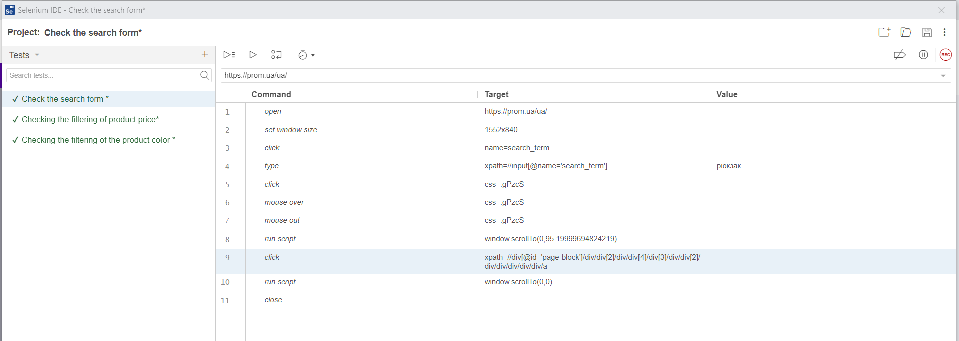

2.

<https://drive.google.com/file/d/1BVb9hix305IPUN7HySucm7AxuDhcmw41/view?usp=sharing>

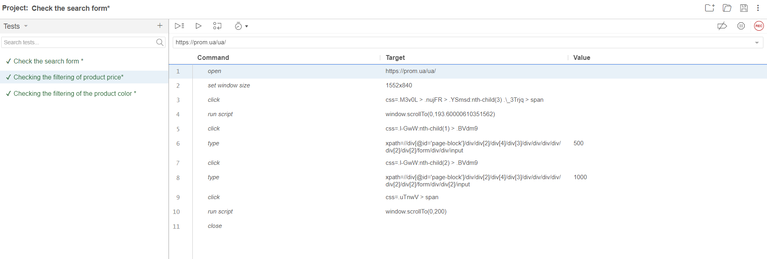

3.

<https://drive.google.com/file/d/1Q-FrEkHim1WJF4M719bcxxlkI_Zs58aV/view?usp=sharing>

